Income Tax
Getting Started
1. Create an account on TurboTax.ca for the previous year (which is the current tax year)
a. For the purpose of this assignment you will need an active and accessible email account. You can set up the account with your own personal information if you like. Be sure to remember your username and password!
b. When you are asked what “tax package” you want to use, request the one that costs $19.99 or their standard package to file. You won’t be filing so the cost doesn’t matter, but it will change how you are asked the proper questions later so it’s important.
c. You will need to answer some questions to help develop a tax profile for each of the scenarios on the pages below. Privacy is important so please don’t use your real name, address, or Social Insurance Number in this assignment. Use the info below for anything that requires your name and address unless it applies to the tax profiles for the assignment:
i. Name: (each tax profile person below, eg. Andrew Warshawski)
ii. Address: 602 Lenore Drive, Saskatoon, SK S7K 6A6
iii. SIN: 000 000 000
iv. Birthday: The day and month don’t matter. Just give them a year that makes them the right age. Eg. 17 years old, born in 2003 (in 2020)
2. For any questions that you are asked leading up to the main tax page, you can answer “no” to most of them. The main page will have a line going across the page with headings that say, income, deductions, etc.
4. Once you get to the tax profile page you will need to create a new return for each scenario on the following pages. Each tax profile will be different so pay attention to the information related to age, income, expenses, and deductions, etc. New returns can be found on the left-hand side of the page.
5. Be careful answering the questions about their financial history as choosing or not choosing certain options will make some pages/forms harder to access.
6. If you are ever unsure about a particular question or terminology, look for highlighted text or advice buttons to guide you and explain things further. If you are still unsure, ask for help.
7. For each scenario, you will need to state the refund/balance owing and take a screenshot of the review summary.
8. DON’T SUBMIT OR FILE ANY OF THE RETURNS!!
7. Lastly, complete the reflection after you have completed all 4 scenarios and submit the assignment with your budget project.

Terminology
A. Before you get started let’s look up a bit of information to help understand tax lingo better.

Define the following terms:

1. Registered Retired Savings Plan (RRSP):

2. Home Buyer’s Plan (HBP):

3. Guaranteed Investment Certificate (GIC):

4. Tax Free Savings Account (TFSA):

B. Answer the following questions:

Use the Canada Revenue Agency website to help you answer the next questions or you can Google them if you get stuck:

1. What is a TD1 form?

2. Why do you need to file a TD1 form?

3. What is the basic tax deduction amount for a federal tax return? (search “TD1 form basic allowance”)

4. What is the basic tax deduction amount for a provincial tax return? (search “TD1 SK form basic allowance”)

5. What does this basic tax allowance mean for federal and provincial TD1 forms?

TAX PROFILE SCENARIOS

Profile 1: Student who works at a fast-food restaurant
Personal Details:
- Andrew Warshawski is 16 and started working at a fast-food restaurant during last tax year.
Work Schedule:
• He earned $11 per hour. His shifts were 4 hours each and Andrew worked an average of three times a week for 48 weeks, for a total of 576 hours worked.
• 4% vacation pay was added to his paycheque each pay period.
T4 Information:
- Andrew didn’t receive an official T4, but he still needs to declare his income. He earned $6,589.44 in the tax year
• No CPP was deducted from his pay.
• EI premiums were deducted and total $90.68.
• Andrew didn’t sign a TD1 form, so his employer had to deduct tax from his cheques for a total of $50.35.
- He needs to declare his amount of EI Insurable Earnings and CPP Insurable Earnings as the same amount as his income from the year
Other Information:
- Andrew doesn’t have any other important information to declare so his tax profile is finished. You can advance to the “Review Summary” page
Answer:
- Use the snipping tool or take a screenshot of the Review Summary page that includes the Refund or Balance Owing in the top left corner and insert the picture below.

Profile 2: Student who works as a server in a pizza restaurant
Start a New Return for Sandy Smith and enter the new information for Sandy from below:
Personal Details:
- Sandy Smith is 17 and works at the local pizza parlor on the weekends.
Work Schedule:
• She usually works a four-hour shift at $12 per hour.
- Without tips her normal pay cheques include work for 4 hour shifts at $12/hour x 156 shifts x 4% vacation pay paid each cheque.
• Sandy earns tips at her job so we will need to declare that amount to the CRA. Pay attention to the tax profile questions and choose “I need to declare tips and other income”
T4 Information:
• Sandy’s T4 total income from her employer’s wage is $7,787.52.
• Sandy submitted TD1 forms, both Federal and SK and she checked that her income wouldn’t exceed her tax credits. Therefore, her employer wasn’t required to deduct tax and Sandy didn’t pay tax for the year.
• Sandy’s employer did deduct $134.72 for EI premiums.
• Sandy isn’t 18 yet, so her employer did not deduct CPP premiums.
- She needs to declare his amount of EI Insurable Earnings and CPP Insurable Earnings as the same amount as his income from the year
Other Income:
- On the “other income” page Sandy will need to declare that she earned $13,500 in total tips for the year
Other Information:
- Sandy doesn’t have any other important information to declare so her tax profile is finished. You can advance to the “Review Summary” page
Answer:
- Use the snipping tool or take a screenshot of the Review Summary page that includes the Refund or Balance Owing in the top left corner and insert the picture below.

Profile 3: Student who is away at university and returns home for summer work
Personal Details:
- Jonathan Smythe is currently 19 years old. He attends university in Alberta for the fall and winter and returns home to Saskatchewan in the summer to work.
- He has not moved or relocated to another province as he only attends school, which means he is still a resident of Saskatchewan.
- In September, of the year before last tax year, he moved to Edmonton, AB to attend the University of Alberta for a Bachelor of Commerce degree. He filed his taxes for the time he attended from September to December of that year and now needs to file them for the January to April semester and the September to December semester of last tax year.
Work Schedule:
• When Jonathan returned home in the summer, he worked 40 hours/week x 17 weeks and was paid $12.50/hour. He worked 5 hours of overtime per week at 1.5x he regular wage and has his vacation pay calculated into his cheques.
- He was a great worker and often earned a bonus at the end of the summer
- Jonathan earns no income after he moves back to Edmonton for the school year.
T4 Information:
- Jonathan received a T4 slip from his employer which shows that he earned $13,617.50 for the summer. A copy of the T4 and other information on it is provided on the next page.
Student Information:
- Jonathan needs to declare that he is a student
- Jonathan receives a T2202 every year that indicates what he has paid the university in tuition. He was a fulltime student and attended school 8 months of the year. His tuition cost was $8500 for the two semesters. His T2202 is located on the next page.
• He is on a scholarship from the university and receives a T4A every year that indicates that he receives scholarship money as a full-time student for $5000 every school year. The T4A is located on the next page.
Other Information:
- Jonathan doesn’t have any other important information to declare so his tax profile is finished. You can advance to the “Review Summary” page
Answer:
- Use the snipping tool or take a screenshot of the Review Summary page that includes the Refund or Balance Owing in the top left corner and insert the picture below.

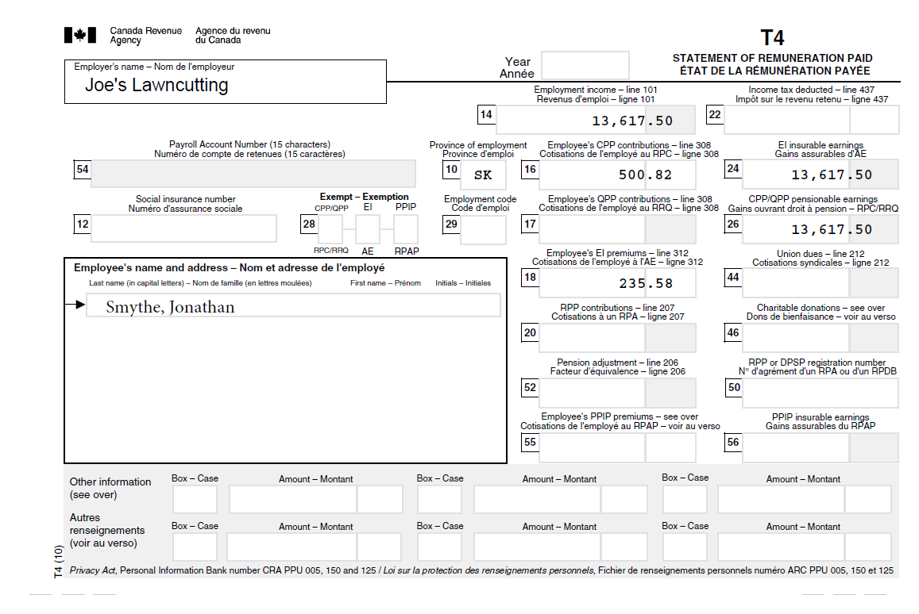

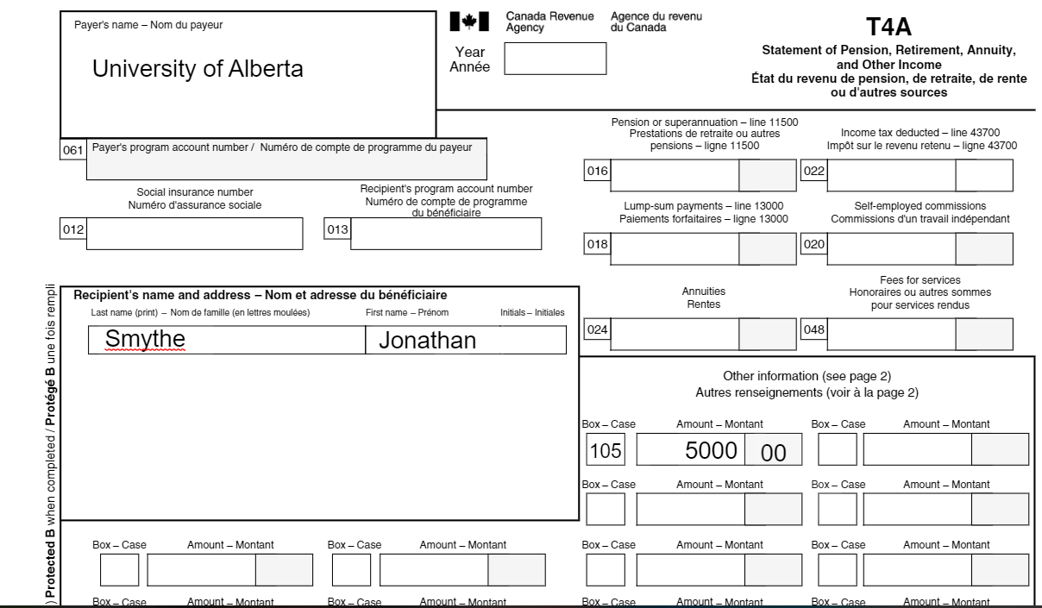

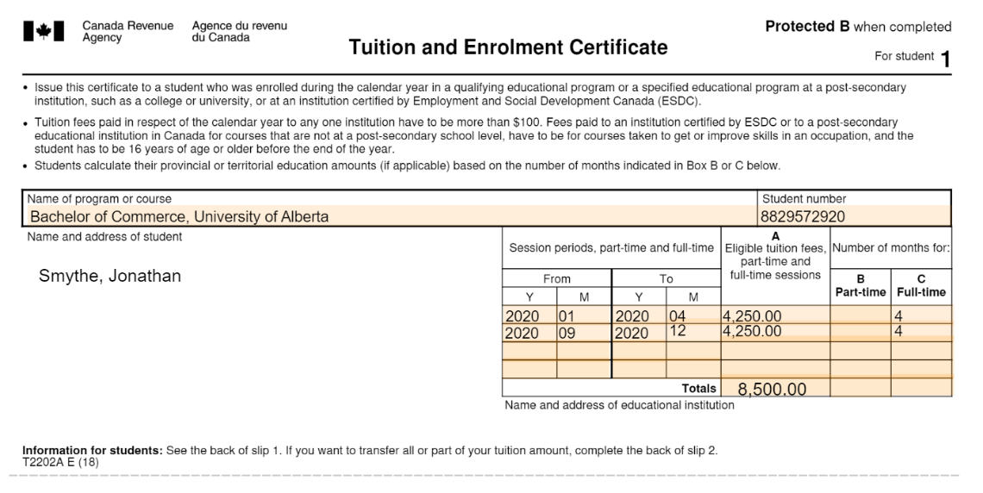

Profile 4: Young Adult with their first full time job
Personal Details:
• Jeannie Grant is 23 years old and works for the city library for her full-time job.
Work Schedule:
- Jeannie makes $15/hour. Hours are from 8:30 to 5 pm, with an hour for lunch, 7.5 hours per day. Jeannie is paid for statutory holidays on each pay cheque.
T4 Information:
- Jeannie receives a T4 stating her income was $29,250. A copy of her T4 is located on the next page.
- The employees at the library are unionized, so she pays union dues of $800 a year.
• There is strong support for the charity, United Way, so Jeannie contributes $50 per month from her pay cheque as a charitable donation. It is taken off her monthly pay cheque and totals $600 for the year.
• As a result of the union, there is a benefit plan, and Jeannie pays extended health and dental plan premiums of $35 every month for a total of $420 for the year.
RRSP Information:
- Jeannie decided to make a Registered Retired Savings Plan (RRSP) contribution in October for $1500 and has a RRSP deduction limit from the previous year of $38,400.
Medical Expense Information:
- Jeannie pays into her health benefit plan, but it doesn’t cover the full expense for every she needs. Over the course of the year Jeannie has a prescription receipt for $100 for medication and was reimbursed $80 from her plan but paid $20 out of pocket. She bought glasses for $600 and was reimbursed $300 but paid $300 out of pocket. She also had her teeth cleaned for $300 and was reimbursed $200 but paid $100 out of pocket. The extra money she paid out of pocket are extra medical expenses beyond her regular dental and health premiums so she can claim the total amount on her income tax under medical expenses. Altogether she paid $420 out of pocket, which needs to be claimed under Medical Expenses
Other Information:
- Jeannie doesn’t have any other important information to declare so her tax profile is finished. You can advance to the “Review Summary” page
Answer:
- Use the snipping tool or take a screenshot of the Review Summary page that includes the Refund or Balance Owing in the top left corner and insert the picture below.

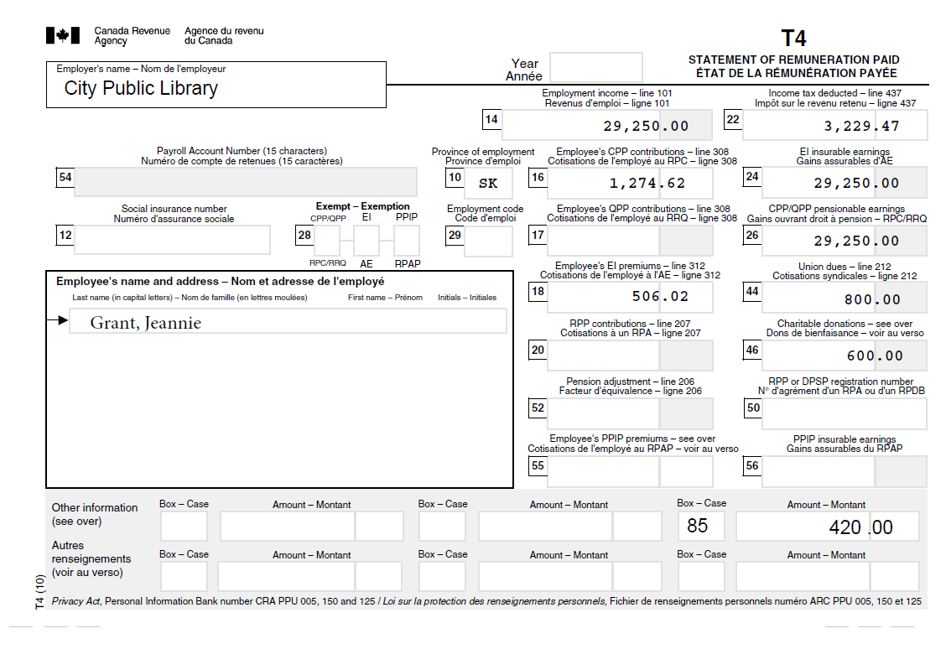

Reflection
1. What was the hardest/most challenging part of doing the different tax scenarios?

2. What was the easiest/least challenging part of doing the tax scenarios?

3. What circumstances/situations can you think of that might make doing your own taxes:
A. Harder?
B. Easier?

4. Do you think you will do your own taxes in the future or pay someone to do them for you? Why or why not?

