Travel Project

Travel Project
In this project, you will be creating a travel plan: focusing on the flights, transportation once you arrive at your destination, the activities and tours you will participate in, and navigating to your locations. You will be using some of the skills you learned previously in the budget project to help you plan this trip.
Your Task:
- You will be typing this plan up on a separate document. This assignment sheet is only to help you plan your trip and answer the necessary questions along the way.
- Destination:
- Select a destination of your choice. You will plan for a week-long trip, so consider where you will go for a week. Travel time to China may not be worth it for a week.
- Trip date: You can pick the time of year but be aware of high and low seasons for travel -Summer and holidays are high season and anything else is usually lower.
- Budget: Will not exceed $4000.00 per person.
- Plan your travel itinerary and hotel choices.
- Consider all parts of the trip using the outline of activities as listed below.

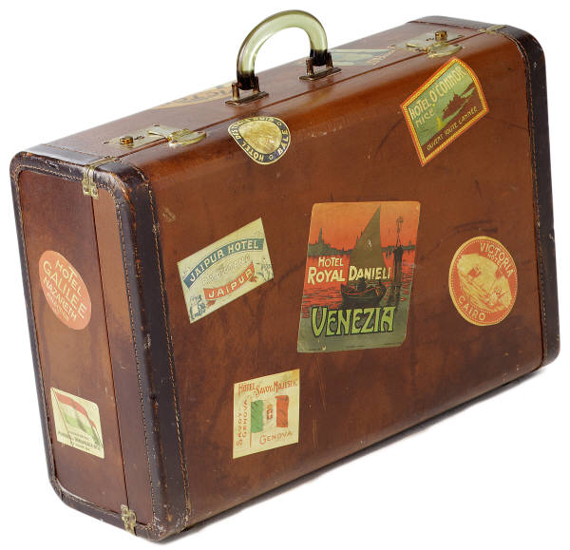
Travel Considerations:
- Getting around: What type of transportation will you use once you are at your destination?
- Location: Where is your accommodation? How far is it from the things you want to see and do?
- Activities: What are you interested in seeing and doing while you are on your holiday? How much will they cost?

1. Destination
Briefly outline the choice you made for your travel destination on your separate travel planning page.
Describe:
- Where are you going? In which country is it located?
- Why did you choose this destination?
- Dates/length of travel?
- Were there any factors that played into your decision on where and when to go? Eg. events, history, sights, culture, etc. Explain.

2. Flights
Explain the flights path you will need to take to get to your destination. Be sure you explore a few different dates, airline companies, and flight paths. Flights can greatly impact the cost of your trip. You can also save money if you are willing to have layovers, and multiple stops.
- When do your flights depart?
- What will they cost?
- Do you have any layovers or gaps in flying time? Will you have to stay overnight somewhere?
- You can provide a screen capture of the flights if it easier to identify some of the information.
Example:
Travel to Kaua’i is by air and it is 3010 miles (4844 km) south west of Canada across the Pacific Ocean.
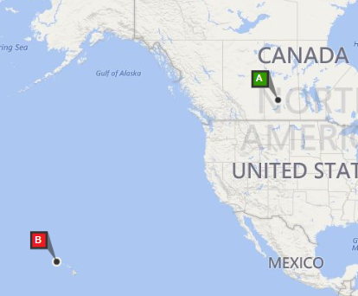
The cost of the flight is $1910.89/person, including taxes & additional fees.
Flights: Departure
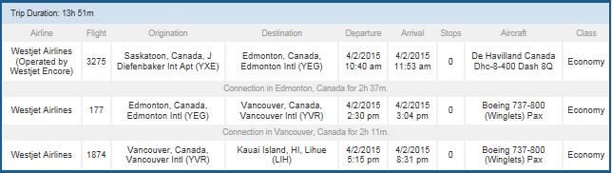
Flights: Arrival
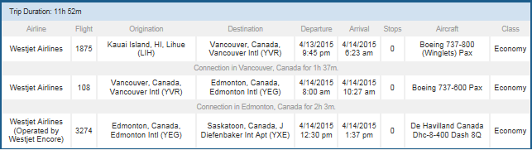

3. Where to Stay?
Choose a place(s) to stay at your destination.
- Where is/are the hotel(s) located?
- How is it rated?
- How much does it cost per night?
- Describe this accommodation and be sure to list its features such as included meals, pool, activities on site, nearby attractions, etc.
Example:
The hotel chosen for our trip to Kaua’i is the Aston Islander on the Beach in Kapa’a, which is on the East Coast of Kaua’i.

It costs $111 per night including all taxes and fees.
http://www.astonislander.com/

I chose this hotel because:
- Its score is 8.1/10 on Booking.com
- It is on the beach and has an oceanfront pool and hot tub, tennis court, and golf course nearby.
- There is free parking available.
- It is located in Kapa’a, which is the shopping centre of Kauai.
- There is free wifi, refrigerator and microwave.
- There is a free continental breakfast.

4. Activities – What to See and Do
There are so many things to do while on vacation!
Make a table similar to the one below to outline 5 options for activities. Make sure all activities are appropriate for this assignment.
- Choose at LEAST one activity and/or restaurant for each day of your holiday. For each one, note what the activity is, the cost, how many hours it will take, and what time of day it is available. Note the address of the activity as well.
Example: Activities for a Holiday in Kaua’i, Hawaii
Activity and Description  (including address/location) | Time Frame | Cost of Activity
- Blue Dolphin Napali Coast Catamaran and Snorkling Tour Port Allen  http://bluedolphinkauai.com/tours/ | 5.5 Hrs  Check-in 7:00 AM (Daily) | $137 to $148
- Snorkling Equipment Rental from Snorkel Bob’s Kapa’a http://snorkelbob.com/ to snorkel at Lydgate Park and Poipu Beach Park. | 1 week rental | $43/week
- ATV Guided Tour Kipu Ranch near Kalaheo  http://www.kiputours.com/ | 3 hours  Mon - Sat: 7:00am or 1:30pm  Sun: 7:00am, 8:00am, 11:30am, or 1:30pm | $148.75 for Single ATV; $125 for 4 passenger ATV
- Fern Grotto and Wailua River Boat Tour http://www.smithskauai.com/smithskauai/cart.html?tickets=fern | 90 minutes  9:30, 11:00, 2:00, or 3:30 departures | $18.00
- Kilauea Lighthouse http://www.gohawaii.com/kauai/regions-neighborhoods/north-shore/kilauea-lighthouse | 2 hours  Tuesday to Saturday 10:00 am to 4:00pm, | $5.00
- Kaua’I Farmers’ Markets  http://www.kauai.com/kauai-farmers-markets | Mon – Thurs different times | Varies

5. Getting Around – Ground Transportation
In some destinations, it is possible to walk, bus, or use the train or a taxi to get to your activities, while in other destinations you will need to rent a car. It is also possible to rent a car for part of your holiday and rely on other types of ground transportation for the rest. Travelling on busses or trains can add to your holiday experience, so it is a great idea to look into the types of transportation that are available to you on your holiday.
- What type of public transportation (bus, train, taxi) is available at your destination?
    - What is the cost?
    - Is the cost per trip or per day?

- What is the cost of a shuttle from the airport/bus terminal to your hotel? Is this a free service provided by the hotel? Can they get you to your activities you have chosen for each day of the trip?

- How much would it cost to rent a car?
    - Look up the cost of renting a car for a day and/or the whole week potentially.
    - What costs are associated with renting a car

- What type of ground transportation would be your best choice for your holiday? Describe your decision and your reasoning.

- Make a chart similar to the one below that indicates what it would cost for you to get around each day of the trip.

Example:
- There is a bus service in Kaua’I http://www.kauai.gov/Government/Departments/TransportationAgency/BusSchedules/tabid/208/Default.aspx
The bus costs is $2.00 per trip, and most routes begin at 6:00 in the morning and run until 10:00 at night, passing through a bus stop about every hour.
- There is no shuttle directly to the hotel and taking the public bus shuttle would require a bus change.
- The trip to Kaua’i will require a car rental, as buses don’t run to the locations for the Kipu Ranch Tour or the Kalauea Lighthouse.
- Car Rental Options in Kaua’i:
Company | Type of car | Costs
Honk, USA | Ford Focus | $33.40/day; $389.06 total price
Advantage | Nissan Versa | $25.50/day; $423.96 total price
Budget | Ford Focus | $33.43/day; $479.65 total price
- Although the daily rental rates are less at Advantage and are the same for Budget and Honk, Budget and Advantage both have lots of ‘extra’ fees that they charge on their car rentals, so Honk is the better choice for a car rental in Kaua’i.

Day | Destination | Activity | Cost of Transportation
1 | Kuaii | Snorkling | Train – $8.00/day pass  Walking from hotel to train station and activity
2 | Honolulu | USS Arizona | Train – $8.00/day pass  Walking from hotel to train station and activity
3 | Honlulu | Volcano/  sightseeing | Car Rental $33.43/day; $479.

6. Finalizing the Budget
Lastly you are going to summarize the full cost of your holiday. You will need to estimate some costs as they may vary from person to person, such as: spending cash/souvenirs, food, tips, etc. Your chart should look similar to the one below when you are done.

To book a vacation to Kaua’I over Easter Break in 2020 it would cost:
Item | Comments | Cost
Flight | 2 stops on the way to Kaua’i  2 stops on the way home | $1910.89
Hotel | Aston Islander on the Beach $111/night | $1221.00
Car Rental | Honk – Ford Focus | $389.06
Activities | Catamaran Tour, ATV Tour, Snorkeling, Fern Grotto Tour, Lighthouse | $389.00
Food | Breakfasts are free  Purchase groceries and store in hotel room’s fridge $10/day  Supper – eat out every night $25/day | $0  $110  $275
Total Fixed Costs |  | $4294.95
WOOPS! Going to Hawaii for 7 nights is $294.95 over the $4000.00 budget. Options are to either cut out some of the paid activities OR reduce some aspect of the vacation like hotel/flights
- Cutting The ATV Tour and Catamaran Tour would reduce the cost to $3971.95
- Choosing a cheaper hotel or flight would reduce the cost even more
What would you do?

